Chapter 19, Solution 86

(a) By definition, g₁₁ = , g₂₁ = .

We let V₁ = 1 V and open-circuit the output port. The schematic is shown below. After simulation, we obtain

g₁₁ = I₁ = 2.7

g₂₁ = V₂ = 0.0
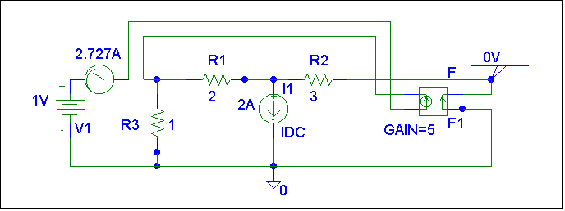
(b) Similarly,
g₁₂ = , g₂₂ =

We let I₂ = 1 A and short-circuit the input port. The schematic is shown below. After simulation,
g₁₂ = I₁ = 0

g₂₂ = V₂ = 0

Thus [g] =

